

Leadership Safeguarding Pathway

Participant Workbook

Chichester Diocese

Name _______________________

Parish / Context _______________________

Role _______________________

Date of Course _______________________

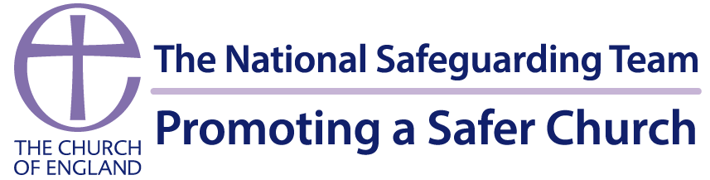

Version April 2026
TABLE OF CONTENTS

1. INTRODUCTION 3
2. LEARNING OUTCOMES 4
3. STRUCTURE 4
4. SAFETY GUIDELINES 5
5. PRE-WORK AHEAD OF SESSION ONE 6
6. PRE-WORK FOR SESSION TWO (completed on the day) 12
7. CONSOLIDATION AND EVALUATION 20
8. FURTHER INFORMATION/RESOURCES 23

1. INTRODUCTION

Welcome to the Leadership Safeguarding Pathway - a space designed to challenge, inspire, and strengthen how we lead. This training isn’t about ticking boxes or memorising procedures. It’s about shaping the kind of leadership that creates safety, models integrity, and builds a culture where people genuinely flourish.
Over the two sessions, we’ll explore what healthy culture looks like, how power and influence can be used well, and how leaders can prevent harm before it happens. We’ll look honestly at what can go wrong, learn from lived experience, and equip ourselves with the insight, confidence, and clarity needed to respond well when concerns arise.
In session 2 of this learning pathway, we use a case study focused upon Mike Pilavachi and Soul Survivor. It is important to acknowledge the survivors of Mike Pilavachi’s abuse but also that not everyone’s experience of Mike Pilavachi or Soul Survivor will have been negative, for many Soul Survivor nurtured their faith and vocation.
Anyone impacted by experience of either Mike Pilavachi himself or of Soul Survivor more widely can speak with their Diocesan Safeguarding Team prior to attending and engaging with the Leadership Safeguarding Pathway.
The aim of the case study is to identify how a comparable situation could be prevented in the future through safe and effective culture, leadership, and capacity.

The National Safeguarding Learning and Development Framework sets out the vision for making sure that all church officers develop an appropriate level of skills and knowledge in safeguarding.
National Safeguarding Learning and Development Framework 2024
https://www.churchofengland.org/sites/default/files/2026-01/safeguarding-learning-and-development-framework-2024-amended-7.1.pdf

2. LEARNING OUTCOMES

The learning outcomes are linked to the National Safeguarding Standards. This pathway offers the opportunity for the following outcomes to be achieved:
- Culture Leadership and Capacity – Examine how, as leaders and influencers within Christian communities, we can shape healthy culture, and effective leadership, resulting in best safeguarding practice.
- Prevention – Explore how safeguarding concerns and abuse can be prevented and how character, charisma, and influence, can shape the experiences of others in church.
- Assess and Manage Risk - Recognise when risk-assessment and risk-management processes are needed and understand when, why, and how they must be used.
- Victims and Survivors – Reflect on how abuse and trauma can affect people’s lives, relationships, and interactions with others in a community setting, leading to better responses to victims and survivors; and
- Learning, Supervision and Support – Assess and apply learning and use it to develop an individual action plan that will improve safeguarding practice and responses.

3. STRUCTURE

The Leadership Safeguarding Pathway is usually delivered either online to small groups, or in-person.
The in-person one day session will consist of two focus sessions and an extended lunch break to review research before session 2. In addition to the day, you will need to complete some pre work and an evaluation task after the final session. The evaluation asks you to reflect on the impact the pathway has had on your learning and how you have, or will, put the learning from this course into practice.
Pre-work is also given ahead of each session and is detailed within this workbook.
This learning pathway includes a range of activities:
- Self-reflective, preparation tasks
- Sections of input delivered via presentation.
- Group participation activities.
- A case study to bring the material to life.
- Additional optional activities and resources to further the learning.

SAFETY GUIDELINES

Anonymity & confidentiality
Participation and discussions within the sessions are private and confidential to the group. Any personal experience shared remains confidential to this group, unless there is a need to share information because someone is at risk.

Safety
There may be people with lived experience in the meeting, please be aware that we will be discussing issues of vital importance, which may trigger feelings and reactions from previous experiences. Please be gentle with each other and yourself. It is important to remember that there may be survivors in the group that have not disclosed their lived experience. Everyone is responsible for their own safety and participation: only share what you feel comfortable with. If you find something triggering it is ok to say so and to do whatever you need to keep safe. Take time out if you need to; please let someone know if you decide to leave early. Support is available if you have lived experience, you can speak with your Diocesan Safeguarding Team, or with Safe Spaces:
Safe Spaces is for anyone who has experienced Church-related abuse, of any type, in England or Wales. Safe Spaces has a team of support advocates who are specially trained in supporting survivors of sexual violence and have received additional training in how churches respond to abuse cases, the way in which faith and Church-related settings have been used to carry out abuse, and the issues affecting people who have had, or still have, a relationship with the Church. You can contact the Safe Spaces team using the following details.
Phone: 0300 303 1056
(answerphone available outside of opening times)
Email: safespaces@firstlight.org.uk
A live chat service is also available through the Safe Spaces website
Opening times: Monday to Friday: 9am to 9pm, Saturdays: 9am to 1pm, Sundays: 1pm to 5pm
Home - Safe Spaces England and Wales

Participation
Your active participation is welcome and encouraged. We all bring valuable wisdom and experiences to share and learn from each other. We hope you will feel able to fully participate to get the most from the group. Please let us know if there is anything else we can do to support your participation and make this the best experience possible.
(email: charlie.parker@chichester.anglican.org)

Inclusion and respect
We bring our diversity of experience and perspectives. Please help us to ensure that all voices can be heard. Let's disagree respectfully and kindly, and approach difference with curiosity rather than the need to be right. We are committed to being inclusive and anti-discriminatory. The Learning and Development Framework at pages 19 and 20 gives options for other ways to access the pathway if you have a disability or difficulty accessing the training, please speak to your Diocesan Safeguarding Team.

5. PRE-WORK AHEAD OF SESSION ONE
(approximately 1 hour)
Ahead of session one we ask that you complete the three tasks below.
Task 1 – Watch one (or two) videos
Task 2 – Culture Cube reflection
Task 3 – Power and Influence Self-Assessment
It is extremely important that you do complete this ahead of the session and is not an optional part of the course.

Task One:
Watch one or two of the Diocese of Newcastle videos. You can select which you watch or watch both.
- Video 1 ‘Would you make me feel safe’

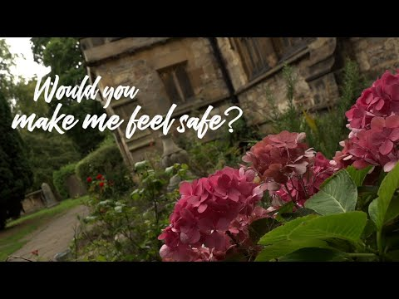

Copy and paste the link below into your web browser if you are having trouble watching the video
https://www.youtube.com/watch?v=J-7pPg-asxE

- Video 2 ‘Would you encourage me to use my voice’

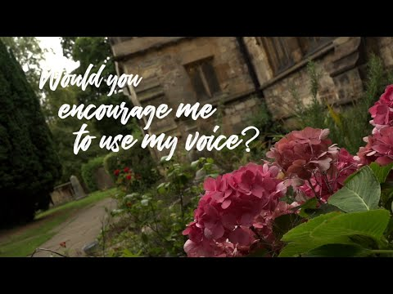

Copy and paste the link below into your web browser if you are having trouble watching the video
https://www.youtube.com/watch?v=cKa-jRFQLVY
Please come to the session prepared to discuss the impact of the videos and what you took from them.

The videos are part of a wider resource ‘If I Told You What Would You Do’ and can be found here: If I Told You, What Would You Do? - Newcastle Diocese https://www.newcastle.anglican.org/if-i-told-you-what-would-you-do-/
(Permission to use the If I Told You What Would You Do resources has been given by the intellectual owners, Reverend John Villaseca and Reverend Rae Caro. The films were designed and written by Dr Sarah Troughton and David Creese, with supporting theological reflections by The Revd Canon Dr Rae Caro and The Revd John Vilaseca. Music written and performed by David Creese.)

Task Two:
Consider the Culture Cube (See template on next page) - this is not a repeat of the last course! Please come to the session prepared to reflect in the group an example of good practice and an example where things could be done differently or better for each area from your context.

Task Three:
Power and Influence Self-Assessment (See Page 8) - consider the different types of power, how they relate to ministry, and your own use of power and influence through a self-assessment document based upon French and Raven’s bases of power. You will not be asked to share your scores during the session.

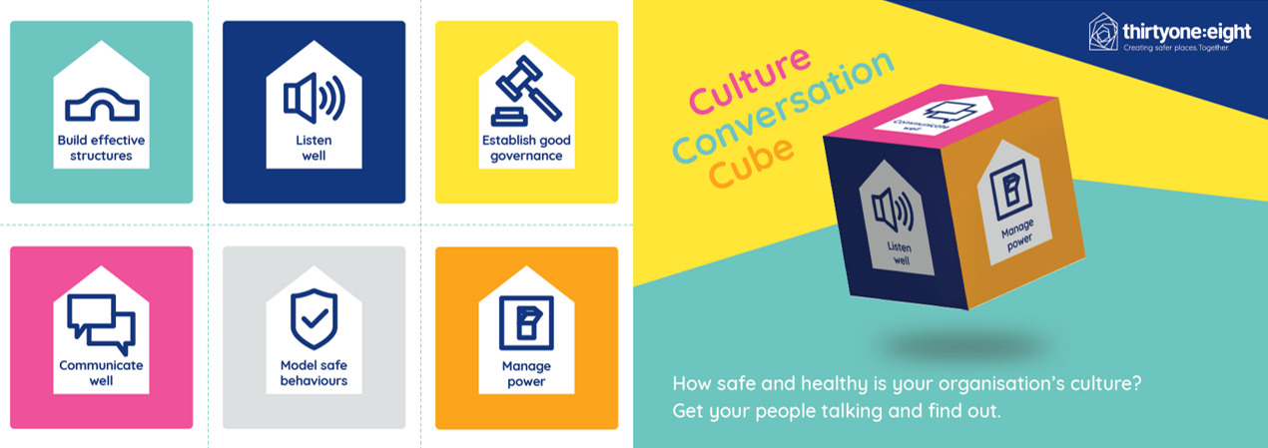  Think about the structures, reporting lines and accountability within your context. | Think about the stories that are being told about your context. | Think about the way your context is controlled and governed. | Think about the formal and informal power structures within your context. | Think about how your context communicates internally and externally. | Think about the everyday activities and behaviours that are accepted within your context.
Good Practice | Good Practice | Good Practice | Good Practice | Good Practice | Good Practice
Area for improvement | Area for improvement | Area for improvement | Area for improvement | Area for improvement | Area for improvement

Power and Influence Self-Assessment

(Based on French & Raven’s Six Bases of Power)

It is important to remember that everyone in a position of responsibility and/or leadership carries some form of power and influence.
Instructions:
For each statement, rate yourself from 1 - 5:
1 – Rarely true of me
2 – Sometimes true
3 – Occasionally true
4 – Often true
5 – Very true of me
Then reflect on the questions that follow each power category.

A. Legitimate Power or Influence – comes from your recognised role, position, or responsibilities.
Statement | 1 |  | 2 |  | 3 |  | 4 |  | 5 |  | Reflection Prompts
People usually look to me for directions because of my role. |  |  |  |  |  |  |  |  |  |  | - How do I ensure I use positional authority with humility?  - Do I ever rely too much on my role rather than relationship?
I feel confident exercising authority when it is appropriate.
I communicate my responsibilities clearly, so others understand my remit.
B. Reward Power or Influence - ability to recognise, encourage, or reward supportive behaviour.
Statement | 1 |  | 2 |  | 3 |  | 4 |  | 5 |  | Reflection Prompts
I intentionally praise or affirm others for their contributions. |  |  |  |  |  |  |  |  |  |  | - Do I use encouragement to build up the Body of Christ?  - Are my rewards (formal or informal) fair, transparent, and generous-spirited?
I help people feel valued and appreciated in their ministry.
I can influence others by highlighting positive outcomes or benefits.
C. Coercive Power or Influence - able to set boundaries or apply consequences when necessary.
Statement |  | 1 |  | 2 |  | 3 |  | 4 |  | 5 |  | Reflection Prompts
I set clear expectations and follow through when commitments are not met. |  |  |  |  |  |  |  |  |  |  |  | - Do I use corrective power sparingly and pastorally?  - How can I ensure discipline is rooted in safeguarding, justice, and compassion?
I feel able to challenge unhelpful or unsafe behaviour.
I use consequences proportionately and with pastoral care.
D. Expert Power or Influence - comes from knowledge, skills, or experience.
Statement |  | 1 |  | 2 |  | 3 |  | 4 |  | 5 |  | Reflection Prompts
People seek my advice because of what I know or have lived through. |  |  |  |  |  |  |  |  |  |  |  | - Do I use my expertise to empower others rather than elevate myself?  - How am I modelling lifelong learning?
I keep developing my skills to serve more effectively.
I share my knowledge generously rather than protecting it.
E. Referent Power or Influence - comes from trust, respect, and relationships.
Statement |  | 1 |  | 2 |  | 3 |  | 4 |  | 5 |  | Reflection Prompts
People feel comfortable approaching me and confiding in me. |  |  |  |  |  |  |  |  |  |  |  | - How does my character reflect Christ-like leadership?  - Do I cultivate trust in healthy, transparent ways?
I try to lead by example in integrity and discipleship.
I intentionally build relationships based on kindness and respect.

F. Informational Power or Influence - ability to influence through sharing/controlling information.
Statement | 1 | 2 | 3 | 4 | 5 | Reflection Prompts
I communicate information clearly and transparently. |  |  |  |  |  | - Do I steward information ethically and safely?  - How do I balance transparency with confidentiality, especially in safeguarding contexts?
I use information to support good decision-making.
I avoid withholding information in ways that could create confusion or mistrust.

Scoring and Interpretation
You can total each section (max 15) or look simply at patterns.
- High scores (11–15):
You use this form of power of influence regularly.
Consider: Is it used for service, empowerment, and wellbeing?
- Medium scores (7–10):
This is a moderate part of your leadership.
Consider: Is there room to develop or balance your approach?
- Low scores (3–6):
You may use this power or influence type less often.
Consider: Would strengthening it improve your ministry? Or is it appropriate to your context?

Closing Reflection Questions
- Which type of power or influence do I rely on most?
- Which type might I need to grow in for healthier leadership?
- How do these power or influence dynamics align with servant leadership and Anglican values?
- How can I use power or influence in ways that promote safety, dignity, and flourishing for all?

6. PRE-WORK FOR SESSION TWO (completed on the day)

There will be an opportunity to look at the case study notes on the day and before the second session. You therefore do not need to read this before the session, but we have provided it for in case you would like to look before.
- Read the summary provided on the following pages of the case of Mike Pilavachi and Soul Survivor which sets the scene for the case study activity within the session.
Optional – “Let there Be Light” is offered as an optional additional preparation activity. The video is 31 minutes long.


Copy and paste the link below into your web browser if you are having trouble watching the video
https://www.youtube.com/watch?v=YVZkgdt32u8&t=1152s

- Reflect on what was discussed in Session 1 – responding well to those who lived experience, healthy culture, managing safeguarding information, relationship dynamics and power. Consider how you can take this forward in your role by answering the question below:
How might your natural leadership style help or hinder the development of healthy cultures?
You may wish to draw on your responses to the Power and Influence Self-Assessment or other frameworks you are already familiar with.

Mike Pilavachi and Soul Survivor
The below information has been sourced from the independent review by Fiona Scolding KC and Ben Fullbrook (2024), known as the Scolding Review; survivor testimony; published news articles about Mike Pilavachi and Soul Survivor and the ‘Let There Be Light’ documentary.

Background Context
Mike Pilavachi, the founder of Soul Survivor and a prominent figure in UK evangelical circles, was investigated by the Church of England following numerous allegations of abusive behaviour. In 2023, an independent safeguarding report by Fiona Scolding QC confirmed that his conduct over several decades was abusive.
Soul Survivor was founded by Mike Pilavachi in 1993. It started within St Andrew’s Church, Chorleywood, and was later based at Soul Survivor Watford, a Church of England congregation. It’s leadership structure included senior pastors, youth leaders, worship leaders, and administrative staff. Many in positions of responsibility did not know the full picture, as the internships and personal relationships operated largely outside formal structures.
Structurally, Soul Survivor was three separate legal entities — Soul Survivor Ministries, Soul Survivor Church, and Soul 61 — each with its own trustee board and charitable registration.
Activities included large annual festivals with up to 30,000 attendees annually, discipleship schools, worship leadership courses, and church planting support. Soul Survivor also produced music albums, books, and teaching materials. The movement played a major role in shaping a generation of young Christians, including many who went into ordained or lay ministry. Mike Pilavachi was widely seen as: charismatic and inspiring, and particularly gifted in reaching young people.
However, alongside this success, an independent review by Fiona Scolding KC and Ben Fullbrook (2024), known as the Scolding Review, found a longstanding pattern of abuse of power within a permissive culture.
Soul Survivor operated under Anglican oversight from the Church of England and partnered with Christian youth ministries across the UK and internationally.
It was Soul Survivor Watford itself that commissioned the independent Scolding Review — funding it entirely from local congregational giving, and they have subsequently implemented all its recommendations in full, demonstrating that organisations can engage in deep and transformative cultural change as a direct result of committing to safeguarding best practice.

Patterns of Abuse
Mike Pilavachi abused the power he held by exploiting his role as a trusted spiritual leader, knowing that those around him respected or idolised him. The Scolding Review highlighted a long-term pattern of coercive and abusive behaviour masked as pastoral care or spiritual mentoring. Mike Pilavachi’s abuse can be described as follows:

- Psychological/Emotional/Spiritual abuse:
- Manipulative use of religious authority to control and manipulate young people.
- Positioning himself as a spiritual father and pressuring young men to submit to his authority under the guise of discipleship.
- Creating a culture where individuals felt they must please him to avoid rejection. People felt unable to speak out due to fear of 'ghosting' or losing status - the culture discouraged disclosure.
- Control and Isolation: Isolating individuals from other sources of support or leadership, effectively monopolising their spiritual and personal development.
- Emotional manipulation: Developed inappropriately intense, dependent relationships, including favouring certain young men and creating exclusive relationships that caused jealousy or emotional distress, among others. Making people feel special or chosen and then withdrawing affection or attention, “ghosting,” as a form of punishment or control.

- Physical abuse:
- Gave private massages to young male interns, often in vulnerable situations. Individuals were sometimes partially clothed and alone with him. Many reported discomfort, shame, and inability to say no. This behaviour was judged to be a serious abuse of power, regardless of intent.
- Wrestling sessions and playfighting which Pilavachi claimed were bonding experiences but which the victims reported as invasive and uncomfortable.
- These activities were often framed as spiritual or mentoring experiences blurring boundaries.

Victim Impact
The victim impact of the Soul Survivor case has been profound and long lasting, affecting survivors’ emotional, spiritual, psychological, and social wellbeing. Survivors came forward with deep personal stories detailing the damage caused both by Pilavachi’ s behaviour and the institutional failures that enabled it.
- Psychological and Emotional Trauma:
- Survivors have reported long term effects including anxiety, depression, PTSD, and complex trauma.
- Many experienced confusion, shame, and guilt, particularly because the abuse was framed as ‘discipleship’ or spiritual mentoring.
- Some said they felt “broken,” “used,” or “manipulated,” often not realising until years later that what they experienced was abusive.
- Spiritual Abuse and Crisis of Faith:
- Survivors describe a deep spiritual betrayal – their abuser was seen as a mentor, a father figure, even a conduit to God.
- Many experienced a crisis of faith, struggling to separate their view of God from their experience of Pilavachi’ s control.
- Some have left their faith entirely, unable to reconcile their experience with a faith that promised safety and truth.
- Loss of Community and Belonging:
- Many survivors were part of a tight-knit Christian communities centred on Soul Survivor. When they spoke out, they were often ostracised or disbelieved.
- Some lost friendships, support systems, and ministry opportunities.
- Victims reported feeling isolated when they realised others in leadership knew or suspected what was going on and said nothing.
- Professional and Vocational Harm:
- Some young men were mentored for leadership roles, but lost experiences, with the 'ghosting' they experienced adversely affecting those who fell out of favour.
- Delayed Recognition of Abuse:
- Because the behaviour was framed as spiritually legitimate, many victims only later realised it was abusive.
- This delay in recognition led to a longer healing process, often with self-blame and difficulty trusting others or institutions.
- Retraumatisation During the Invest decision making:
- Victims have said the Church of England’s safeguarding process was often retraumatising citing poor communication, lack of pastoral support, and having to retell their stories multiple times.
- Some said they felt used again, this time by a system that promised justice but delivered delay and emotional turmoil.
- Public acknowledgement of the abuse and an apology were issued in 2023, which was welcomed but felt like it was too little too late.

Institutional Failures
The Soul Survivor case involving Mike Pilavachi revealed serious institutional failures within the organisation and the wider Church of England. No formal complaints about Mike Pilavachi were recorded in the Church records at any time; informal concerns were not properly escalated to allow for investigation.
The Scolding Review identified serious safeguarding failures:
❗ Safeguarding System Weaknesses
The focus of safeguarding practice at the time was largely in children and formally defined vulnerability; adult victims of power abuse were not recognised as safeguarding concerns. Boundary violations (wrestling, massage, control) were not recognised or acted upon, and concerns were not recorded, reported to safeguarding professionals or followed up. Safeguarding systems were underdeveloped.
There were three separate legal entities to Soul Survivor: Soul Survivor Ministries, Soul Survivor Church (SSW), and Soul 61 — each with its own trustee board and charitable registration. Scolding identifies the opacity and poor communication between these structures as a core enabling factor in the failures. For example, disclosures made to Ministries trustees did not automatically reach Church trustees.
For many years, Soul Survivor operated with limited formal oversight from the Diocese. Even after formal recognition in 2014 under a Bishops Mission Order, oversight remained light touch, the “visitor” role had limited influence, and no robust accountability mechanisms were enforced.
❗ Concerns and Complaints Were Not Properly Handled
Informal concerns were not properly escalated. The 2004 complaint and the 2016 allegation were inadequately handled. Evidence suggests that some leaders and trustees knew elements of what was happening and that wider patterns of behaviour were visible over time but despite this, concerns were minimised, and action was inconsistent or absent.
❗ Culture of Silence
Staff and volunteers feared consequences for speaking out. Staff and volunteers did not know how to raise concerns, did not trust that concerns would be acted on and feared being excluded or “ghosted”. There were no effective whistleblowing systems, safe reporting channels or independent routes for escalation.
❗ Lack of Accountability
Leadership structures centred too much around one charismatic figure. A culture developed that was highly relational and informal, dependent on one central leader who was resistant to criticism. Boundaries between friendship and leadership and pastoral care and control were blurred and poorly understood. Recruitment and roles were often informal and personal (“Mike asked me”) and based on relationship rather than process. Internship and leadership pathways lacked clarity, structure, and supervision, and created dependency on the leader. There were no robust HR systems, performance management, or role clarity.
❗ Failure to Manage Power Imbalance
Institutional structures did not recognise or address the asymmetry of power between leader and young people, or the influence of spiritual authority. No safeguards existed to limit dependency or prevent exploitation of influence.

Key Lessons for Faith Leaders
✅ Safeguarding Applies to Everyone
Leaders must recognise their influence. No leader is exempt from boundaries, however gifted or respected.
- Success and gifting must not excuse behaviour.
- “Fruit of ministry” cannot justify harm.
- No leader is beyond challenge.
✅ Healthy Leadership Requires Accountability
Ensure:
- External oversight
- Transparent recruitment and decision-making.
- Clear supervision structures
✅ Safe Environments and Activities
- “Low-level” behaviours matter - boundary crossing, over familiarity
- Informal structures can lead to increased risk.
- Never meet in ways that reduce visibility or accountability.
- No private physical contact
- Pastoral work should be open and observable.
✅ If I Told You What Would You Do?
Create a culture where:
- People can question leadership.
- Safeguarding worries are welcomed, not feared.
- There are safe, trusted reporting mechanisms.
- Whistleblowing is encouraged.
- Concerns are taken seriously and acted upon
✅ Watch for “Special” Relationships
Avoid:
- Favouritism
- Secrecy
- Emotional dependence
- Exclusive mentoring arrangements
✅ Build a Safe Ministry Culture
A healthy church culture is:
- Humble
- Transparent
- Accountable
- Survivor-focused
Chronology of events
Date | Event
7 March 1958 | Michael (Mike) Pilavachi was born in London, of Greek Cypriot heritage.
1974 | Mr. Pilavachi became a Christian following a conversion experience at age 16.
1987 | Mr. Pilavachi became a full-time youth minister at St Andrew’s, Chorleywood, aged 29.
1993 | Mr. Pilavachi founded the Soul Survivor summer festivals.
1993 | Soul Survivor Church began, emerging from St Andrew’s Chorleywood (Church of England).
2004 | Safeguarding concerns relating to Mr. Pilavachi’ s behaviour were raised with him and the Chair of Trustees. The complaint was inadequately managed.
2005–2006 | Mr. Pilavachi met with the Chair of Trustees and asked whether he should stop “horseplay and rough and tumble.” He was advised to stop.  This was Mike Pilavachi proactively soliciting the advice, not leadership proactively challenging him.
2008 | Mr. Pilavachi later stated that David Westlake (Trustee) advised him to stop giving massages.  David Westlake denies any knowledge of the massages until 2023; there may be confusion between wrestling (which Westlake did advise on) and massage.
2012 | Mr. Pilavachi was ordained as a Deacon in the Church of England.
2013 | Mr. Pilavachi was ordained as a Priest in the Church of England.
2014 | Soul Survivor Church became subject to a Bishop’s Mission Order (BMO).
2016 | Mr. Pilavachi was made an Honorary Canon of St Albans Cathedral.
2016 | An allegation was made that Mr. Pilavachi touched a man in a sexualised way while giving a massage.
2019 | The Soul Survivor summer festivals ended.
2020 (New Year Honours) | Mr. Pilavachi was appointed MBE for services to young people.
July 2020 | Mr. Pilavachi received the Archbishop of Canterbury’s Alphege Award for Evangelism and Witness.
Early 2023 | Allegations relating to Mr. Pilavachi were reported in the press.
April 2023 | Mr. Pilavachi stepped back from making decisions and subsequently resigned from positions connected with Soul Survivor.
2023 | An internal safeguarding investigation into Mr. Pilavachi and others was conducted by the Church of England National Safeguarding Team and the Diocese of St Albans.
November 2023 | The Trustees of Soul Survivor commissioned an Independent Review into the culture, leadership, and safeguarding practice.

7. CONSOLIDATION AND EVALUATION

In evaluating this training what really matters is whether the “learning experience” has affected your beliefs, values and understanding at a deep level so that you are sufficiently prepared to engage in this work. We want to know that you now do things not because you must do them, but because you really want to exhibit those behaviours. This is called “second order” change – when people do things because there is an inner motivation.
So, if this “learning experience” has been effective, you will, in some respects, be a different person from the one that started the experience. The purpose of the evaluation, then, is to try to find out if any difference has indeed been achieved and whether after completing this training, you feel that you have been sufficiently prepared for the role you are undertaking.
At the beginning we set out the learning outcomes the programme is designed to deliver, and they are repeated here.
The learning outcomes are linked to the National Safeguarding Standards. This pathway offers the opportunity for the following outcomes to be achieved:
- Culture Leadership and Capacity – Examine how, as leaders and influencers within Christian communities, we can shape healthy culture, and effective leadership, resulting in best safeguarding practice.
- Prevention – Explore how safeguarding concerns and abuse can be prevented and how character, charisma, and influence can shape the experiences of others in church.
- Assess and Manage Risk - Recognise when risk-assessment and risk-management processes are needed and understand when, why, and how they must be used.
- Victims and Survivors – Reflect on how abuse and trauma can affect people’s lives, relationships, and interactions with others in a community setting, leading to better responses to victims and survivors; and
- Learning, Supervision and Support – Assess and apply learning and use it to develop an individual action plan that will improve safeguarding practice and responses.
The evaluation task
Reflecting on the preparatory tasks that you have completed, and the discussions from the two sessions of the pathway, complete the self-reflection and action plan below which asks you to identify what impact this pathway has had on your learning and what you can practically do to take this learning forwards within your own context.
The evaluation task should be submitted within six weeks of completing session two.
Reflection & Action Points
Reflect:
What role do I play as a leader in my context in enhancing the safeguarding culture?

How has learning from this pathway impacted on how you see your role as a leader?

Action Plan
Developing a 4–6-month action plan will allow you to implement new and observable leadership behaviours which deliver concrete safeguarding outcomes and demonstrate that safeguarding is increasingly intuitive and at the heart of everything you do.
When developing this action plan consider how you would demonstrate the learning gained to:
- Shape a healthy culture, effective leadership, and safeguarding for all.
- Promote healthy cultures in your area of responsibility through your behaviours, using your influence positively.
- Embed safeguarding principles in your beliefs and values.
- Support others in their understanding and practice of safeguarding.
- Demonstrate reflection on their practice or experiences of safeguarding.

When creating your action plan think “SMART”
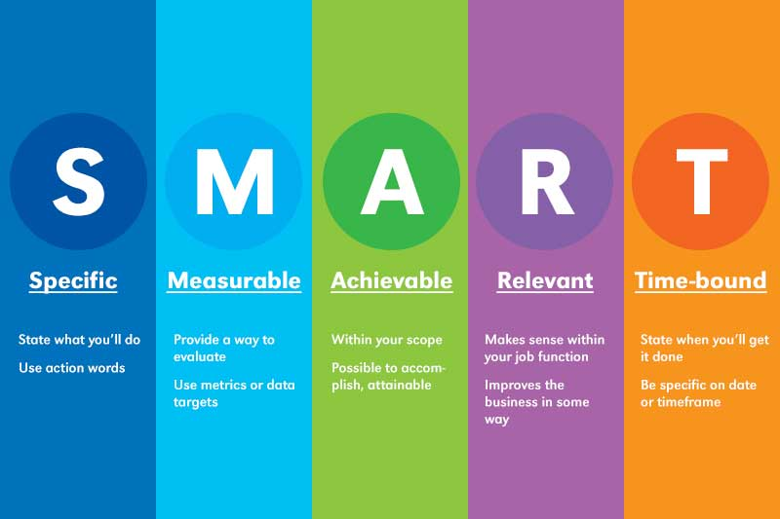
We would suggest that you develop 3-4 objectives for the next 6-8 months.
Objective  What would you link to achieve/ implement | Task/s  What do you need to do | Success Criteria  What will it look like if you achieve your objective | Timescale  When would you like to achieve this
Create an environment in which Safeguarding is not feared but spoken about openly, beyond process and policy | Safeguarding is discussed at PCC beyond reporting. | Discussions surrounding safeguarding in PCC’s are not a tick box but an open dialogue, in which we can explore how to create a safe space. | 6 months

8. FURTHER INFORMATION/RESOURCES

These resources have been highlighted by a variety of people as being helpful for thinking about some aspects linked to safeguarding, some may be referenced in the sessions.
Please be aware that they can be challenging and may contain triggers so please do look after yourself and seek the help and support that is right for you.
If you are aware of other resources that would be useful to share, please contact Louise Warner Louise.Warner@LeicesterCofE.org .
The links below are to Googledocs, to help make it easier to find the resources that are of interest and always give you access to the most up-to-date resource list. You can access the resource lists without needing a Google account.
If needed you can download a document by clicking File, Download and select a file format that works for you, or you can email it to yourself. You can also use Edit, Select All, Copy and Paste. You do not need to request Edit Access
Links to the resources
Books: Safeguarding Related Books.docx - Google Docs
Mixed Media: Mixed Media Safeguarding Linked Resources.docx - Google Docs
Reports and Reviews: Reports and Reviews Safeguarding Linked.docx - Google Docs
Church of England
Safeguarding e-manual | Safeguarding e-manual | The Church of England  https://www.churchofengland.org/safeguarding/safeguarding-e-manual
Parish Safeguarding Toolkit | Parish Safeguarding Resources | The Church of England  https://www.churchofengland.org/safeguarding/safeguarding-e-manual/parish-safeguarding-resources
Guidelines for the Professional Conduct of Clergy | The Guidelines | The Church of England  https://www.churchofengland.org/resources/clergy-resources/guidelines-professional-conduct-clergy/guidelines
National Safeguarding Standards | National Safeguarding Standards | The Church of England  https://www.churchofengland.org/safeguarding/national-safeguarding-standards

