

Safeguarding leadership pathway

Participant workbook

  - Name:
  - Role:
  - Diocese or Cathedral: Chichester

Introduction and Rationale for the Leadership Training.
The national Safeguarding Learning and Development Framework sets out the vision for making sure that all church officers develop an appropriate level of skills and knowledge in safeguarding. A ‘church officer’ is anyone appointed or elected to a post or role by or on behalf of the Church, whether they are ordained or a layperson, paid or unpaid.
We recognise the important role leaders play in creating and maintaining a safe environment for everyone, in whatever way they support the work of the Church. We are committed to helping leaders to develop and maintain the knowledge, attitude, behaviours and skills needed to safeguard and protect children, young people and vulnerable adults.

The safeguarding leadership pathway supports our vision. It is essential that we understand safeguarding as a theological essential, rooted in the nature and love of God, and demonstrated through basic commitments to valuing everyone equally.

We are committed to developing a set of National Safeguarding Standards as part of a quality-assurance framework. The quality-assurance framework will do the following.
- Ask and answer the question, ‘How well are we doing and what is the difference or outcome being achieved?’
- Analyse the answers to this question to gain learning and strengthen the Church’s understanding of, and expertise in, safeguarding.
- Use that expertise to achieve systematic change and continuous improvement in both the quality and impact of our work, and to increase our knowledge and understanding of the changing nature of
Church-based abuse.

This learning pathway has been built around the National Safeguarding Standards.
(National Safeguarding Standards | The Church of England)

Training Requirements

- You have now received your workbook. Please bring this to the session either as a print copy or electronically.

- Please email your completed pre work five working days before the class to
charlie.parker@chichester.anglican.org
- You can do this by attaching the pre work form to the email or writing answers directly into the body of the email

- Please also watch the video about Social Graces which can be found on the portal here:
- Course: Social Graces | Safeguarding: Training Portal

- This is a 90-minute session made up of three exercises which focus on culture, leadership, and capacity and prevention.

- This is a 90-minute session focused on recognising, assessing and managing risk, and victims and survivors. It uses a case study which focuses on how healthy culture and leadership can prevent safeguarding concerns from escalating.

- You need to complete this after the second session to appropriately evaluate the outcomes of the course, what you have learnt from it and how you will put this into practice. You can either do this during the training day or send it afterwards to tasksubmission@chichester.anglican.og within six weeks.
- Please note that you will not receive your safeguarding certificate until you have completed your evaluation and action plan.

Useful documents referred to in training and for reflections.

The National Safeguarding Standards

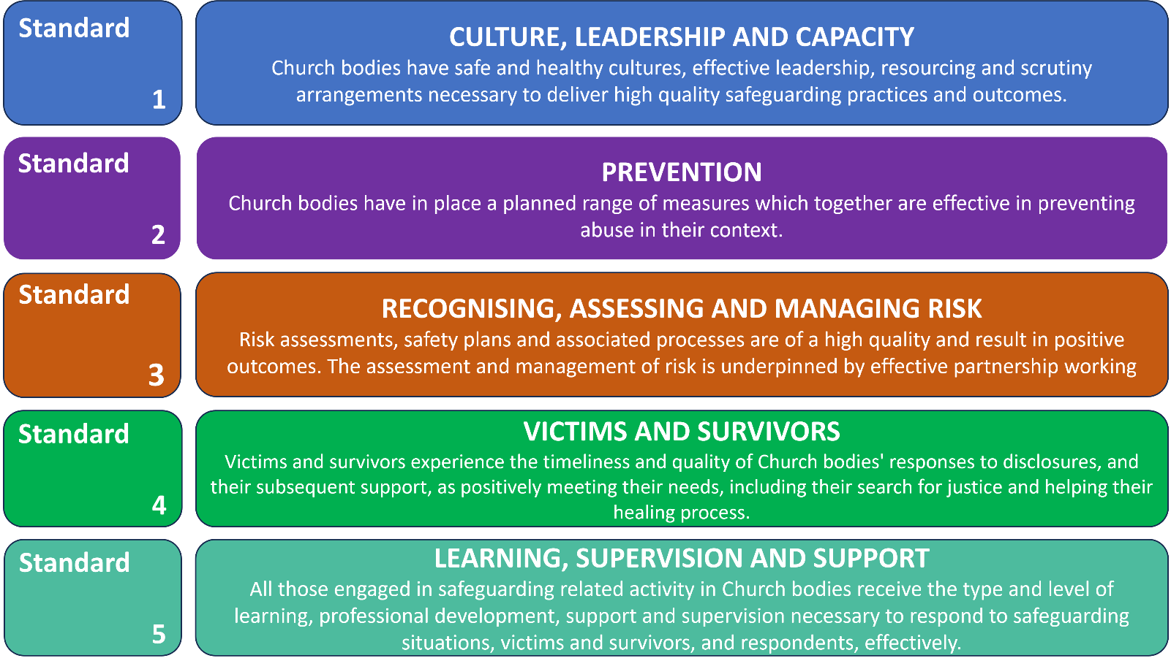

The Code of Safer Working Practice and the Guidelines for the Professional Conduct of Clergy may help with your response to the ‘model safe behaviours’ topic.
The Code of Safer Working Practice:
Code of Safer Working Practice 02.07.2021.pdf (churchofengland.org)
The Guidelines for Professional Conduct of the Clergy:
The Guidelines | The Church of England

Pre course tasks
- Identify what has influenced your values and beliefs regarding safeguarding.
Please identify one thing that reflects what has influenced your individual connection with safeguarding and what your values and beliefs regarding safeguarding are based on. For example, this might be linked to song lyrics, nature or literature, or may depend on your own theology, religious scripture or teachings.
Please ensure this is sent to your trainer before the session. There will be an opportunity to reflect but you will not be asked to share personal experiences with the group. We will be reflecting on how our influences shape responses, values and beliefs regarding safeguarding.
Examples
Thomas Jefferson / Mahatma Gandhi “The true measure of any society can be found in how it treats its most vulnerable members.”
“Speak up for those who cannot speak for themselves, for the rights of all who are destitute. Speak up and judge fairly; defend the rights of the poor and needy.” (Proverbs 31:8).
Proverb: “It takes a village to raise a child.”
And you shall love the Lord your God with all your heart and with all your soul and with all your mind and with all your strength.’ The second is this: ‘You shall love your neighbour as yourself.’ There is no other commandment greater than these.” Mark 12:30-31 (English Standard Version)

Question 1

What has influenced, and therefore supports, your values and beliefs regarding safeguarding?

Question 2
On a scale of 0 to 10, where 0 is 'not at all confident’ and 10 is ‘extremely confident’, how confident are you in recognising and managing risk? What supports your score?

Question 3
What safeguarding risks exist in your own church? What are you worried about?
- What challenges have you experienced in managing a known safeguarding risk?
- How should these risks be managed or reduced? (And how are they managed or reduced?) What’s working well and what can we do to improve?
Case study – please read before attending the training session

Setting
- Place: Anytown – a mid-size market town in an agricultural county. It has a population of around 15,000. There are no other towns nearby, just villages and farms. Anytown is the hub for services, shopping, education and leisure activities for a large, and mostly rural, surrounding area.
- Church: St Ethelburga’s – a mid-size church in the middle of Anytown. St Ethelburga’s has a congregation of around 80, including a small number of young people. A larger number of young people ‘hang around’ the church but don’t attend. Anytown does not have a youth club or anything similar. Several of the young ‘hangers-on’ have said they would attend a youth group if the church ran one.

Main characters
- Matthew (age 35): Matthew is the vicar. He has been at St Ethelburga’s for seven years, and it is his first post. The congregation had dwindled under the previous vicar, who had been there for 25 years until retirement, but Matthew has slowly been bringing people back since he arrived. Matthew would love to run a youth group himself but does not have time with his other commitments.
- Emma (age 33): Emma is Matthew’s wife. She runs the Sunday School and Messy Church, which have been very successful.
- Kate (age 27): Kate came back to the church following Matthew’s arrival. She runs a mother and toddler drop-in group which meets at the church on weekday mornings. Kate also helps Emma runs the Sunday School and Messy Church.
- Clive (age 67): Clive, a retired probation officer, is the parish safeguarding officer (PSO). He was appointed soon after Matthew’s arrival. Before Clive, the parish had not had a PSO for several years. Clive has worked closely with Matthew, Emma, Kate and others to get the parish’s safeguarding back ‘on track’ from where it was when he took over.
- Christopher (age 29): Christopher is an accountant. He’s very friendly and open and is currently single. He went to Bible college after school and has done some overseas mission work. He lives out of town and joined St Ethelburga’s three months ago. He gives the impression of being ‘in tune’ with the young people in the church as he has similar tastes in things like music and fashion.

Scene 1
Christopher has been going to almost every service at St Ethelburga’s since he arrived three months ago. He is popular, energetic, and seems very devout. He has been helping at tea and coffee mornings and has said he would love to join the worship band, which plays at the ‘contemporary’ service once a month (he plays guitar). He has been getting to know the young people in the church, chatting with them after the service, and knows the names of some of the other young people who hang around the church but don’t attend services. He has also got to know the wider congregation and appears to just be very friendly and engaging with everyone.

Evaluation task for AFTER the training day.
Bringing together and evaluating the learning

Traditionally, evaluation in safeguarding training – across all sectors, not just the Church – tends to focus on people reporting on their own experience of a training session they have attended. The problem with this is that it doesn’t really tell us whether training is having any effect. Do people just attend a training event, tick a box on the evaluation sheet and then carry on as before?

The evaluation that really matters is whether the learning experience has affected someone’s beliefs, values and understanding so deeply that there is a change in their behaviour. They now do things because they really want to, not because they have to. This is called ‘second order’ change and means that people do things because there is an inner motivation.

If this learning experience has been effective, you will, in some respects, be a different person from the one who started the experience.

The purpose of evaluation is to try to find out if the training has changed you.
At the beginning of the workbook, we set out the learning outcomes the programme is designed to deliver, and we have repeated them below.
By the end of this pathway, you will:
  - understand how safeguarding concerns and abuse can be prevented in your church;
  - understand how healthy culture, and safe and effective leadership, shapes Christian communities that are healthy, safe and able to deliver high-quality safeguarding practices;
  - recognise when risk-assessment and risk-management processes are needed and understand when, why and how they must be used;
  - understand more about how abuse and trauma can affect people’s lives, relationships and interactions with others in a community setting, leading to better responses to victims and survivors; and
  - evaluate your learning and use it to develop an individual action plan that will improve your safeguarding practice and responses.

If this learning programme has been successful, there will be evidence of the above behaviours, and other people will be able to see a change in your behaviour.

The evaluation task

On the day or by 1st March 2025 complete the self-reflection (on the next page) to show how you have applied the learning from this pathway. Write an action plan which shows three to four ways that you will include what you have learnt in your safeguarding practices. Once you have completed your self-reflection and action plan, send them to the facilitator for them to review.

Leadership safeguarding pathway – self-reflection and action plan

Your name: _____________________________Location: ____________________________

Role: ____________________________________________ Date: ____________________

It is important that our leaders maintain the knowledge, attitudes and skills needed to safeguard and protect children, young people and vulnerable adults. They must also understand safeguarding as a theological essential, rooted in the nature and love of God and demonstrated in behaviour, attitudes and language that give equal value to everyone.
The overall aim is to bring about a shift in our relationship with safeguarding, so that guarding the safety of others flows from the very core of all our behaviour. Safeguarding is more than about ticking a box – it must be at the heart of everything we do.

Self-reflection
Having now completed the leadership safeguarding pathway, please reflect on what you have learnt from the sessions and how you have included this in your practice.
- What difference have you noticed in your approach to safeguarding? (For example, think about knowledge, attitude, language, importance and inclusion within your work.)

- What opportunity do you have, or could you use, to create a healthy church community?

- What would it look like for you to demonstrate behaviour that gives equal value to everyone?

Action plan
Developing a four- to six-month action plan will allow you to practise new leadership behaviour which others can see and which achieves real safeguarding outcomes. It also demonstrates that safeguarding is becoming increasingly natural to you and is at the heart of everything you do.

When developing this action plan, consider how you would use what you have learnt to:
  - reflect on how safeguarding concerns and abuse could be prevented in your church;
  - consider how healthy culture, and safe and effective leadership, shapes Christian communities that are healthy, safe and able to deliver high-quality safeguarding practices;
  - recognise when risk-assessment and risk-management processes are needed and understand when, why and how they must be used;
  - understand more about how abuse and trauma can affect people’s lives, relationships and interactions with others in a community setting, leading to better responses to victims and survivors; and
  - evaluate what you have learnt and use it to develop an individual action plan that will improve your safeguarding practice and responses.

When creating your action plan think ‘SMART’.
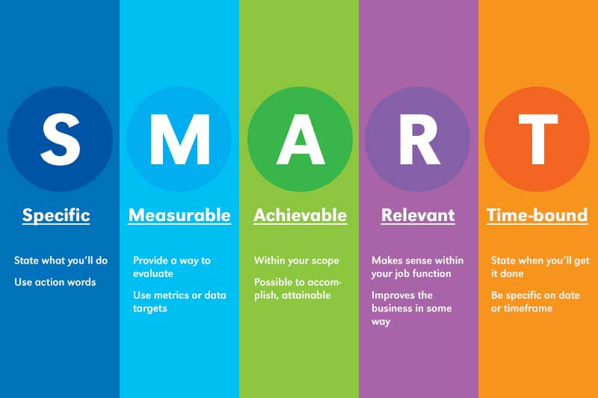

We would suggest that you develop three to four objectives for the next six to eight months.
It would also benefit your own learning and church to discuss your action plan with colleagues who might be able to support or contribute to your action plan.

Objective  What would you like to achieve? | Tasks  What do you need to do? | Criteria for success  What will it look like if you achieve your objective? | Timescale  When would you like to achieve this?
Create an environment in which safeguarding is not feared, but is spoken about openly (not just in processes and policies) | Safeguarding is discussed at Parochial Church Council (not just when reporting safeguarding concerns) | Discussions surrounding safeguarding in Parochial Church Councils are not a box-ticking exercise, but are an open dialogue in which we can explore how to create a safe space. | Six months

