**Leadership safeguarding pathway – self-reflection and action plan**

Your name: _____________________________Location: ____________________________

Role: ____________________________________________ Date: ____________________

It is important that our leaders maintain the knowledge, attitudes and skills needed to safeguard and protect children, young people and vulnerable adults. They must also understand safeguarding as a theological essential, rooted in the nature and love of God and demonstrated in behaviour, attitudes and language that give equal value to everyone.

The overall aim is to bring about a shift in our relationship with safeguarding, so that guarding the safety of others flows from the very core of all our behaviour. Safeguarding is more than about ticking a box – it must be at the heart of everything we do.

**Self-reflection**

Having now completed the leadership safeguarding pathway, please reflect on what you have learnt from the sessions and how you have included this in your practice.

1. What difference have you noticed in your approach to safeguarding? (For example, think about knowledge, attitude, language, importance and inclusion within your work.)
2. What opportunity do you have, or could you use, to create a healthy church community?
3. What would it look like for you to demonstrate behaviour that gives equal value to everyone?

**Action plan**

Developing a four- to six-month action plan will allow you to practise new leadership behaviour which others can see and which achieves real safeguarding outcomes. It also demonstrates that safeguarding is becoming increasingly natural to you and is at the heart of everything you do.

When developing this action plan, consider how you would use what you have learnt to:

* + reflect on how safeguarding concerns and abuse could be prevented in your church;
  + consider how healthy culture, and safe and effective leadership, shapes Christian communities that are healthy, safe and able to deliver high-quality safeguarding practices;
  + recognise when risk-assessment and risk-management processes are needed and understand when, why and how they must be used;
  + understand more about how abuse and trauma can affect people’s lives, relationships and interactions with others in a community setting, leading to better responses to victims and survivors; and
  + evaluate what you have learnt and use it to develop an individual action plan that will improve your safeguarding practice and responses.

When creating your action plan think ‘SMART’.

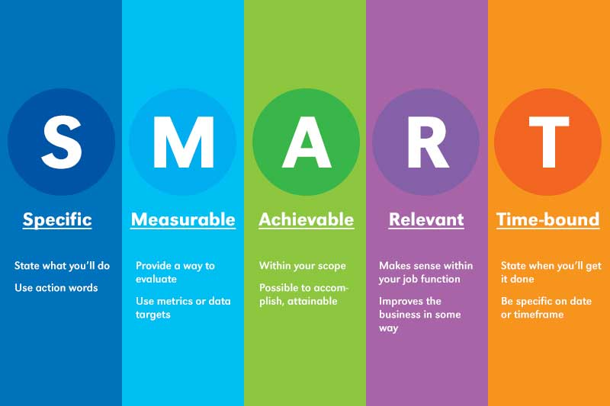

We would suggest that you develop three to four objectives for the next six to eight months.

It would also benefit your own learning and church to discuss your action plan with colleagues who might be able to support or contribute to your action plan.

|  |  |  |  |
| --- | --- | --- | --- |
| **Objective**  **What would you like to achieve?** | **Tasks**  **What do you need to do?** | **Criteria for success**  **What will it look like if you achieve your objective?** | **Timescale**  **When would you like to achieve this?** |
| Create an environment in which safeguarding is not feared, but is spoken about openly (not just in processes and policies) | Safeguarding is discussed at Parochial Church Council (not just when reporting safeguarding concerns) | Discussions surrounding safeguarding in Parochial Church Councils are not a box-ticking exercise, but are an open dialogue in which we can explore how to create a safe space. | Six months |
|  |  |  |  |
|  |  |  |  |
|  |  |  |  |
|  |  |  |  |