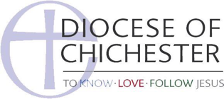**Guidance on writing job and role descriptions.**

Job/role descriptions are useful generally as they help you to focus on the qualities you are looking for in applications, and also help people to know what is expected of them (and what is not). In safeguarding terms, they are also particularly useful as they help to evaluate whether a particular role is eligible for a criminal record check or not.

The few simple questions below provide a straightforward framework to help you consider how to write job/role descriptions in your church. With regards to DBS eligibility, this document should be used alongside the eligibility guidance document for DBS checks, available in the same section of the website.

Job Description – What are the tasks?

What are the expectations? E.g. frequency, working with others, training

Who is the role accountable to/supported by? E.g. Team Co-ordinator, Activity Leader, Vicar

Person Specification – what is needed to do the job? E.g. skills and experience, qualities and personality, knowledge, availability